User Manual
- First, in the console, navigate to the folder and run the corresponding command to execute the app
- Backend dotnet run
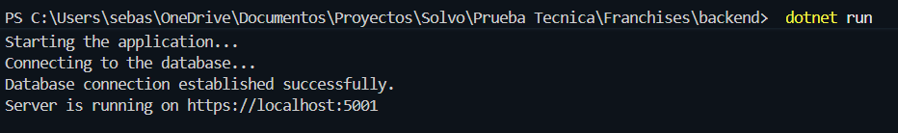
- As a second method to run the backend, in Visual Studio Code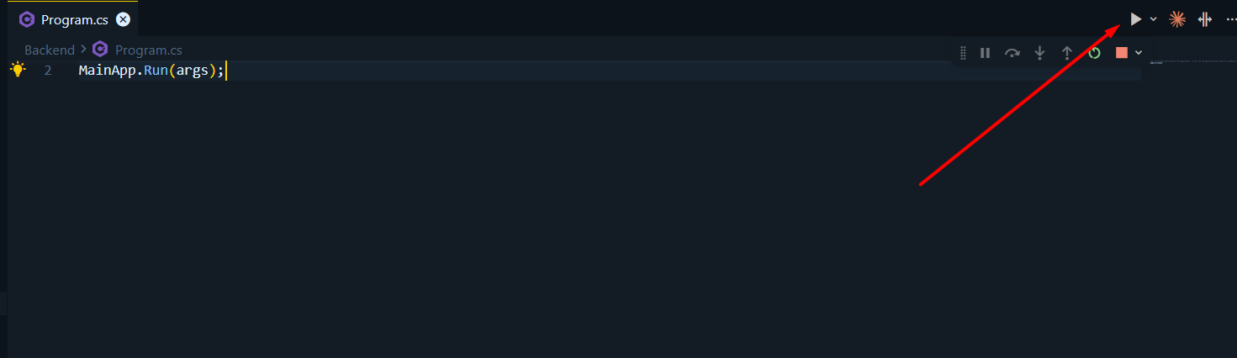
- Frontend npm run dev
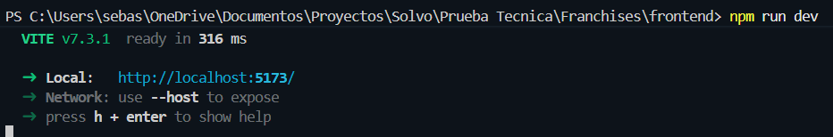

- To perform backend testing, go to https://localhost:5001/swagger/index.html Access this link after running the backend.
- The available routes are:
Franchise
- GET /getFranchises
- GET /getFranchise/{id}
- POST /createFranchise
- PUT /updateFranchise/{id}
- DELETE /deleteFranchise/{id}

Branches
- GET /getBranches
- GET /getBranchById/{id}
- GET /getBranchByIdFranchise/{franchiseId}
- POST /createBranch
- PUT /updateBranch/{id}
- DELETE /deleteBranch/{id}

Products
- GET /getProducts
- GET /getProduct/{id}
- GET /getProductByIdBranch/{branchId}
- POST /createProduct
- PUT /updateProduct/{id}
- DELETE /deleteProduct/{id}

- After running the frontend, you should go to http://localhost:5173/. The first interface is the franchise interface, which allows you to create, delete, and update franchises.
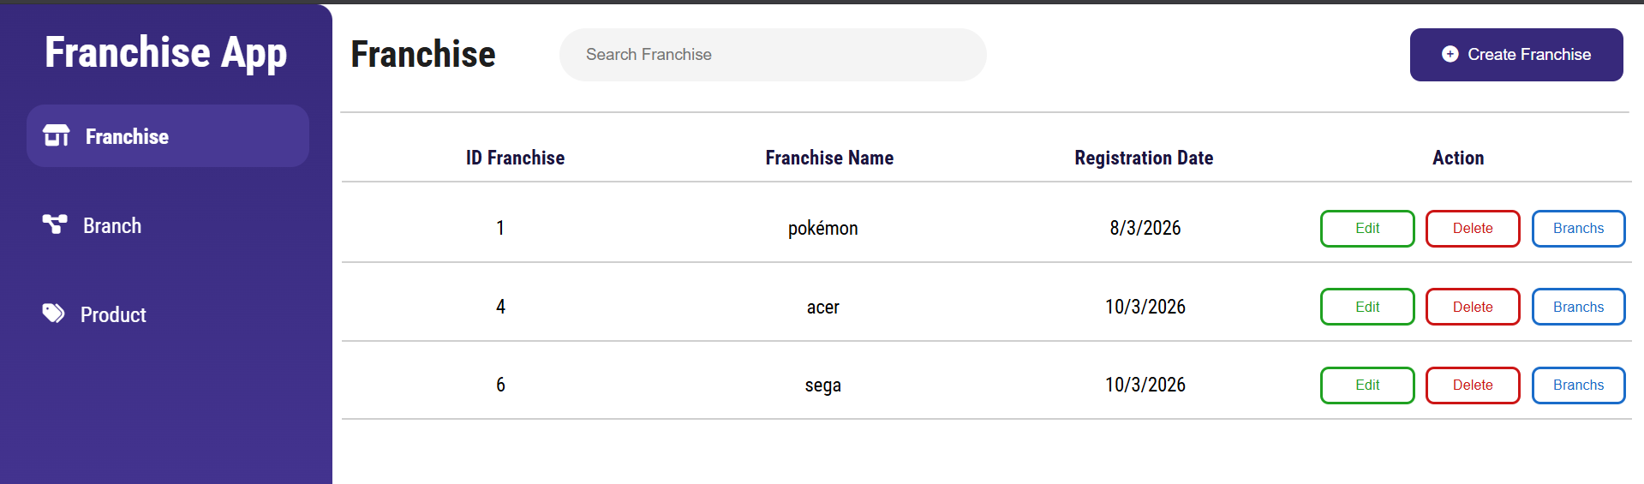

- Clicking the "Create Franchise" button will open a form to enter the franchise name.
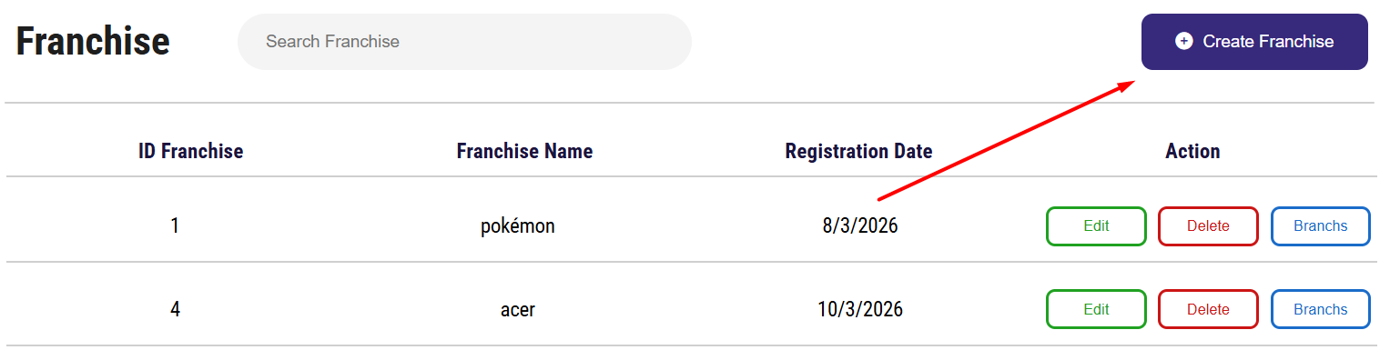
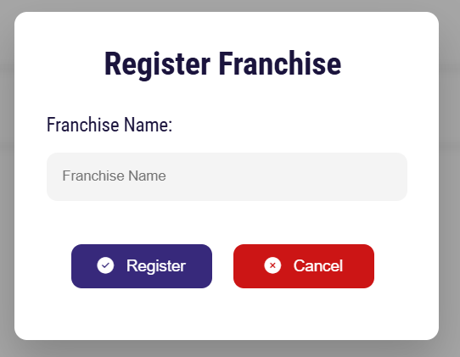
- Clicking the Branch button allows you to create new branches of that franchise, displaying a form to enter the branch details.
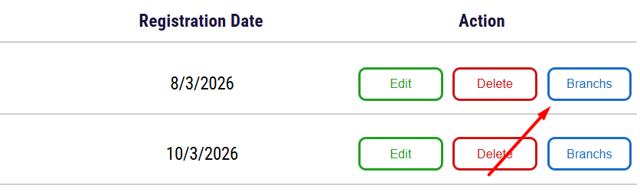
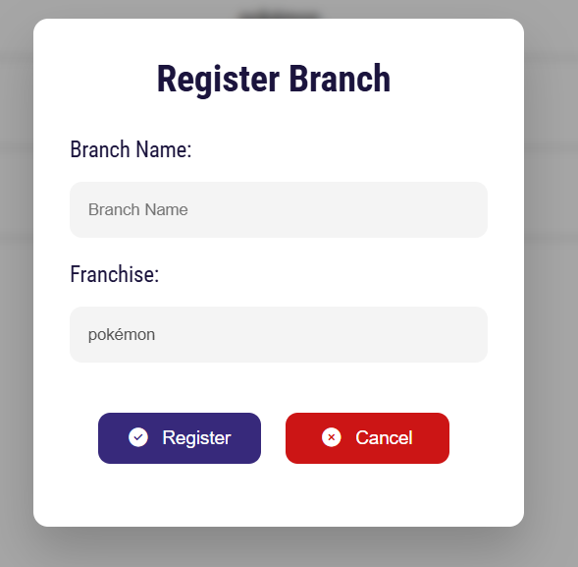

- In the branch interface, you can create, update, delete, and filter information.
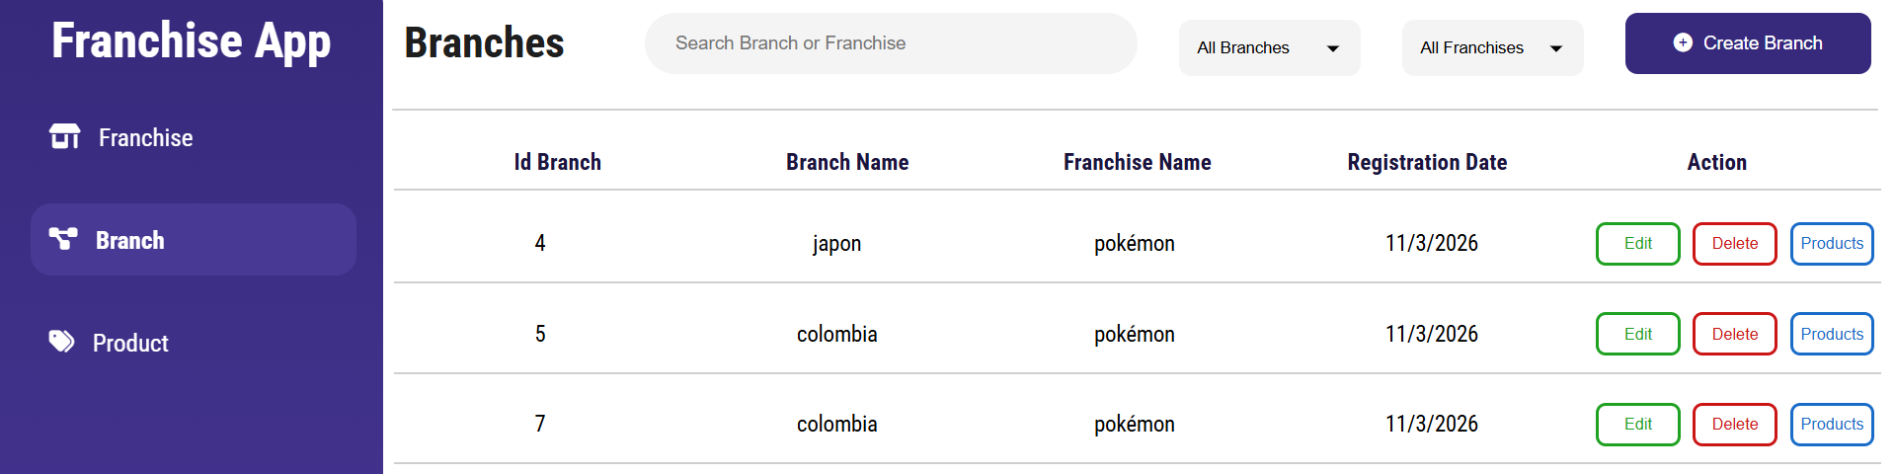

- In the Branch, if we click on product, we can create new products related to that branch.
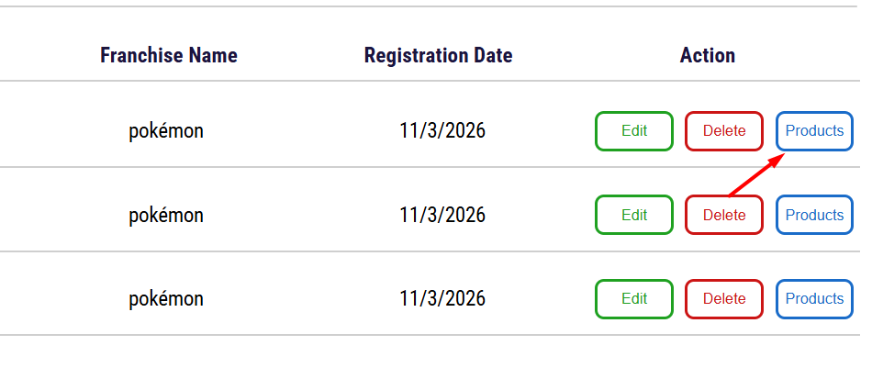
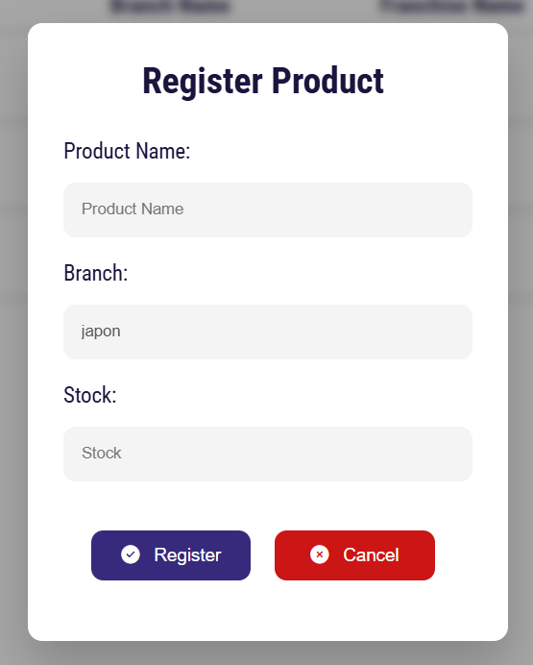

- Finally, we have the product interface where we can perform basic CRUD operations.
